Supplemental Experimental Procedures

1. Structural characterization data of compounds 4a–4h.

Supplementary Fig. 1. ¹H NMR spectrum of the trifluoroacetate salt of compound 4a.

Supplementary Fig. 2. ¹³C NMR spectrum of the trifluoroacetate salt of compound 4a.

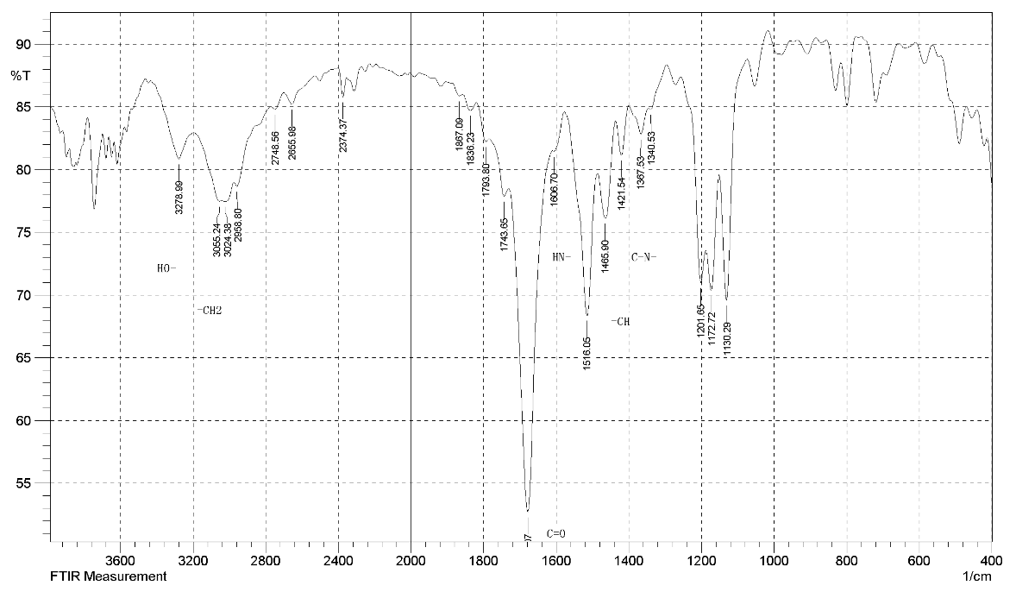
Supplementary Fig. 3. IR spectrum of the trifluoroacetate salt of compound 4a.

Supplementary Fig. 4. ¹H NMR spectrum of the trifluoroacetate salt of compound 4b.
Supplementary Fig. 5. ¹³C NMR spectrum of the trifluoroacetate salt of compound 4b.

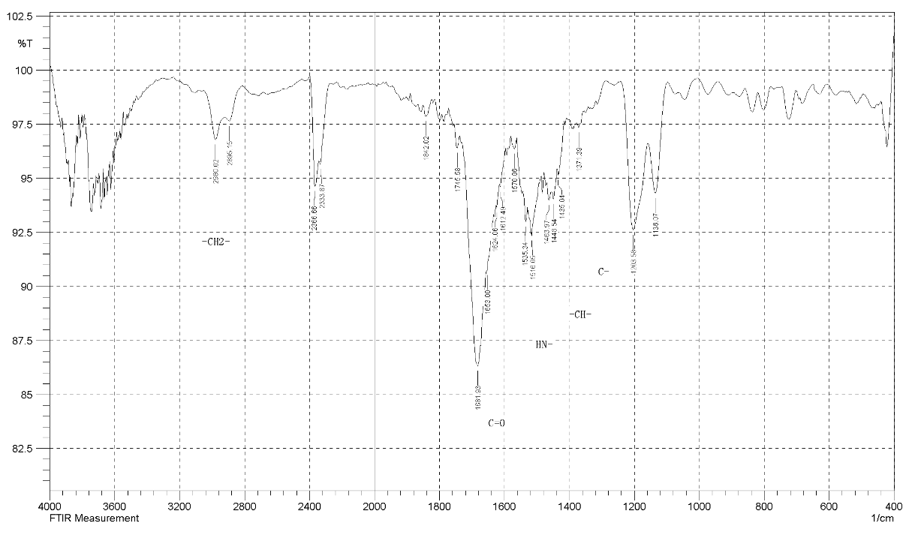
Supplementary Fig. 6. IR spectrum of the trifluoroacetate salt of compound 4b.
Supplementary Fig. 7. ¹H NMR spectrum of the trifluoroacetate salt of compound 4c.

Supplementary Fig. 8. ¹³C NMR spectrum of the trifluoroacetate salt of compound 4c.
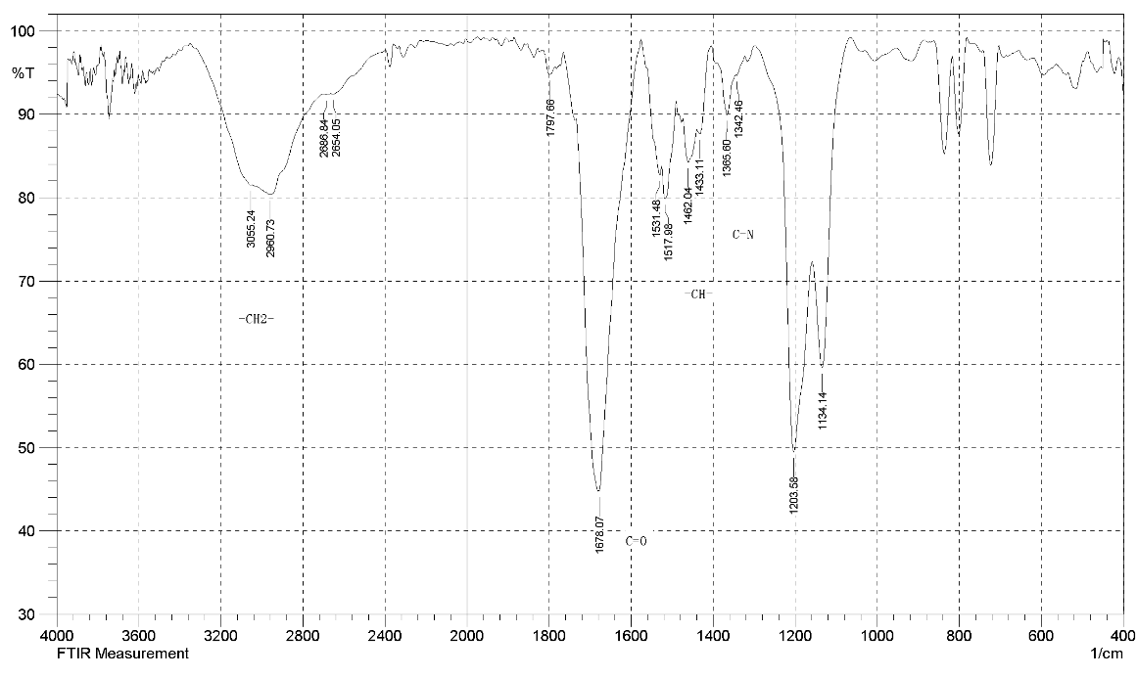
Supplementary Fig. 9. IR spectrum of the trifluoroacetate salt of compound 4c.

Supplementary Fig. 10. ¹H NMR spectrum of the trifluoroacetate salt of compound 4d.
Supplementary Fig. 11. ¹³C NMR spectrum of the trifluoroacetate salt of compound 4d.

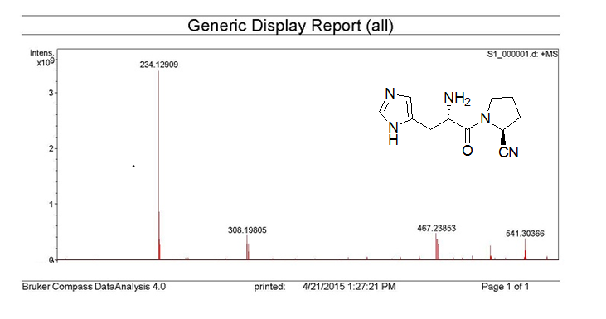
Supplementary Fig. 12. MS spectrum of the trifluoroacetate salt of compound 4d.
Supplementary Fig. 13. ¹H NMR spectrum of the trifluoroacetate salt of compound 4e.

Supplementary Fig. 14. ¹³C NMR spectrum of the trifluoroacetate salt of compound 4e.
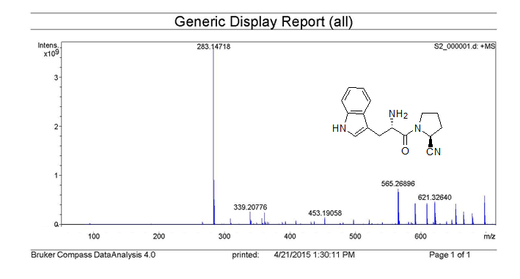
Supplementary Fig. 15. MS spectrum of the trifluoroacetate salt of compound 4e.

Supplementary Fig. 16. ¹H NMR spectrum of the trifluoroacetate salt of compound 4f.
Supplementary Fig. 17. ¹³C NMR spectrum of the trifluoroacetate salt of compound 4f.

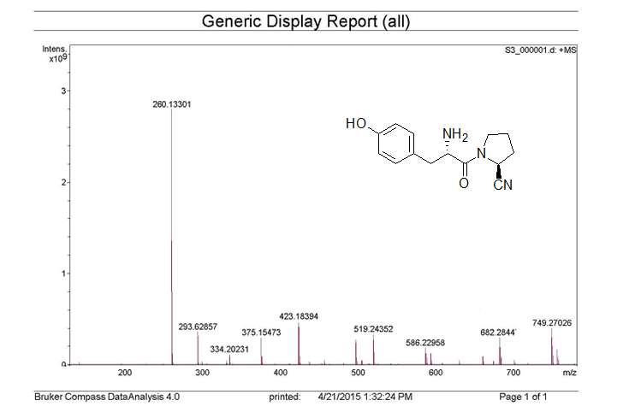

Supplementary Fig. 18. MS spectrum of the trifluoroacetate salt of compound 4f.
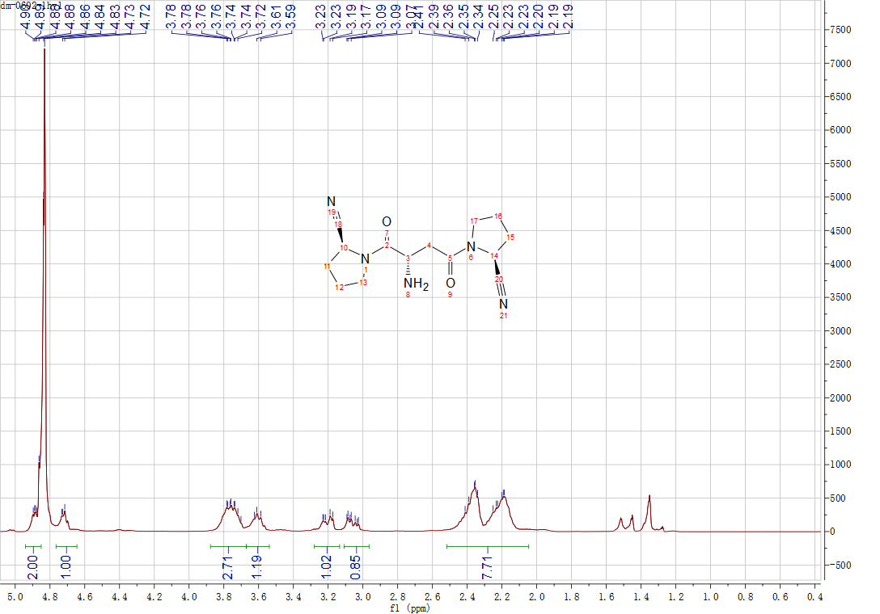
Supplementary Fig. 19. ¹H NMR spectrum of the trifluoroacetate salt of compound 4g.

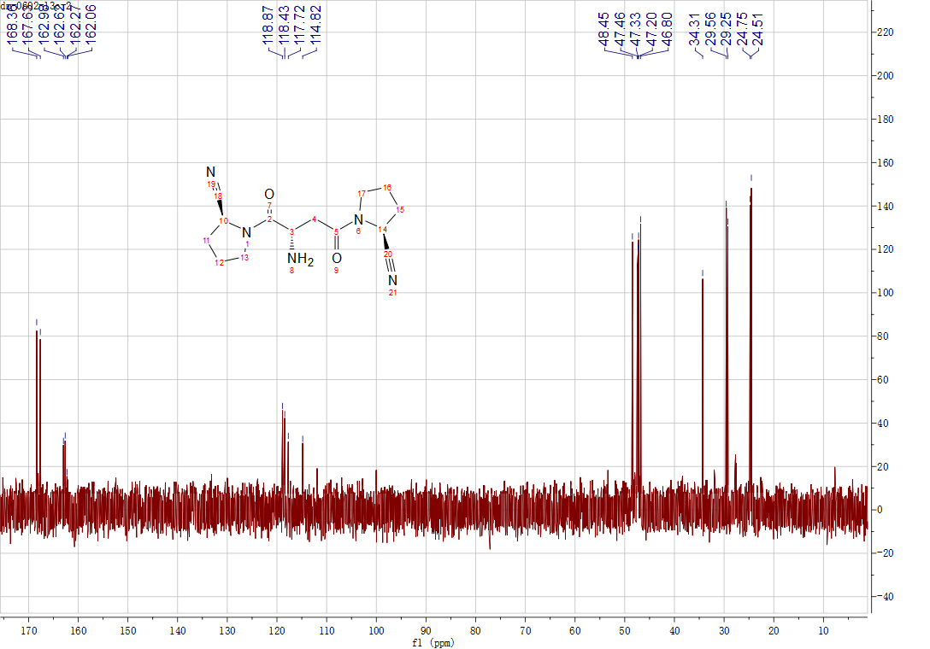
Supplementary Fig. 20. ¹³C NMR spectrum of the trifluoroacetate salt of compound 4g.
Supplementary Fig. 21. ¹H NMR spectrum of the trifluoroacetate salt of compound 4h.

Supplementary Fig. 22. ¹³C NMR spectrum of the trifluoroacetate salt of compound 4h.

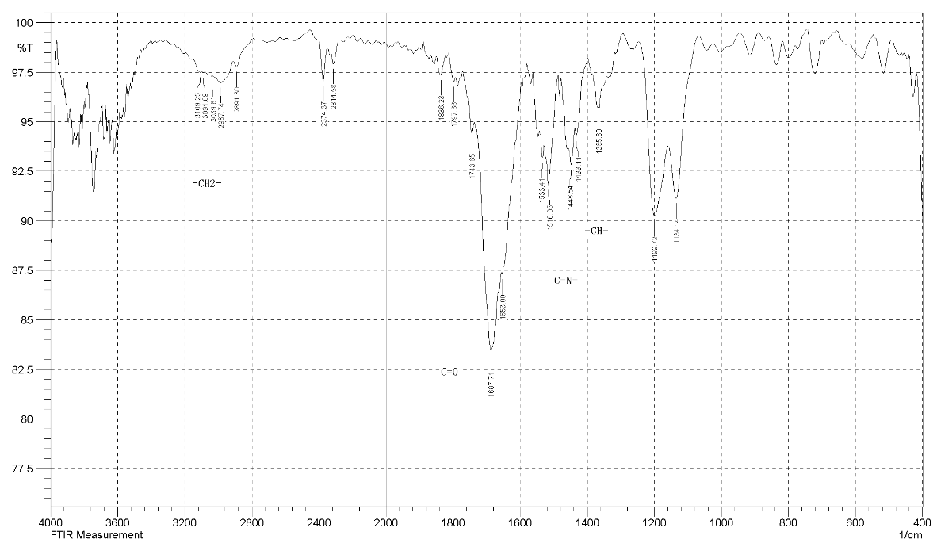
Supplementary Fig. 23. IR spectrum of the trifluoroacetate salt of compound 4h.

2. DPP-4 enzyme inhibition assay
The assay was performed using the DPPIV-Glo™ Protease Assay Kit (Promega, Madison, WI, USA) according to the manufacturer’s instructions. Briefly, serial 5-fold dilutions of each test compound (starting from 100 μM for sitagliptin, and from the indicated starting concentrations for compounds 4a–4h) were prepared in 100% DMSO. Then 2 μL of each dilution was transferred to a white 384-well plate, followed by 8 μL of DPP-4 enzyme solution (final concentration 0.5 nM). The mixture was pre-incubated at 25 °C for 15 min, then 10 μL of substrate (Gly-Pro-aminoluciferin) was added. After 60 min of incubation at 25 °C, luminescence was measured on an EnVision Multilabel Plate Reader (PerkinElmer). Max signal (0% inhibition) was defined by wells containing DPP-4 and substrate without inhibitor; Min signal (100% inhibition) was defined by wells containing substrate without enzyme. Percent inhibition for each well was calculated as: % inhibition = (Max – sample) / (Max – Min) × 100. All experiments were performed in triplicate (three independent biological replicates, each with duplicate technical wells). IC₅₀ values were derived by nonlinear regression (log[inhibitor] vs. response, variable slope) using GraphPad Prism 5. Dose-response curves of DPP-4 inhibition by the reference drug sitagliptin and synthesized compounds 4a–4h. Data points represent mean ± standard deviation (SD) of three independent experiments performed in triplicate (n = 3). Percent inhibition was calculated relative to Max (no enzyme, 0% inhibition) and Min (DPP-4 only, 100% inhibition) controls. Curves were fitted using GraphPad Prism 5 (version 5.01) by four-parameter logistic regression (log[inhibitor] vs. response, variable slope). The fitted IC₅₀ values and corresponding SDs are summarized in Table 1 of the main manuscript.
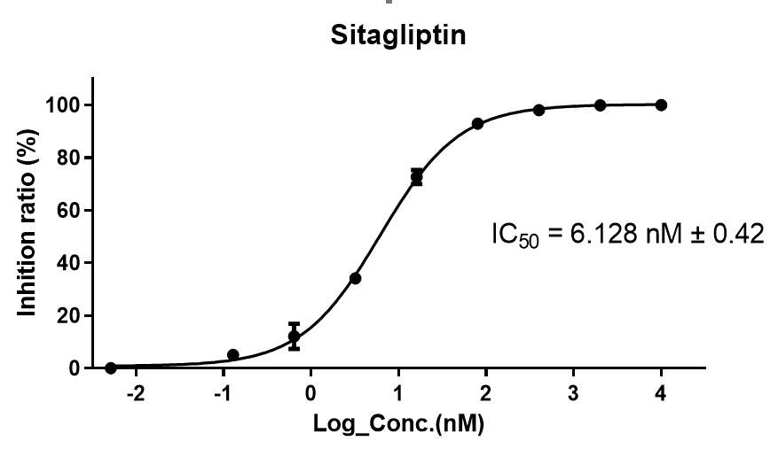
Supplementary Fig. 24. IC₅₀ of compound Sitagliptin
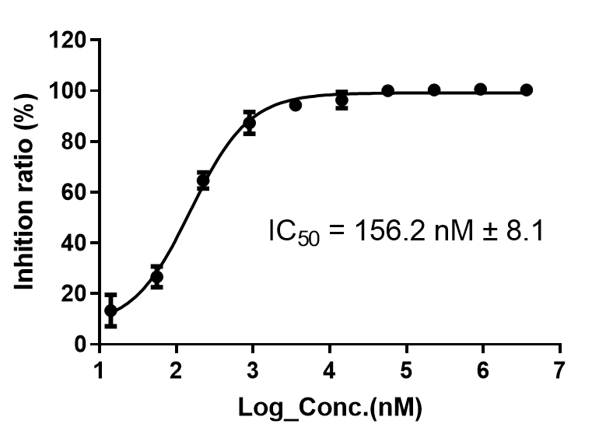
Supplementary Fig.25. IC₅₀ of compound 4a
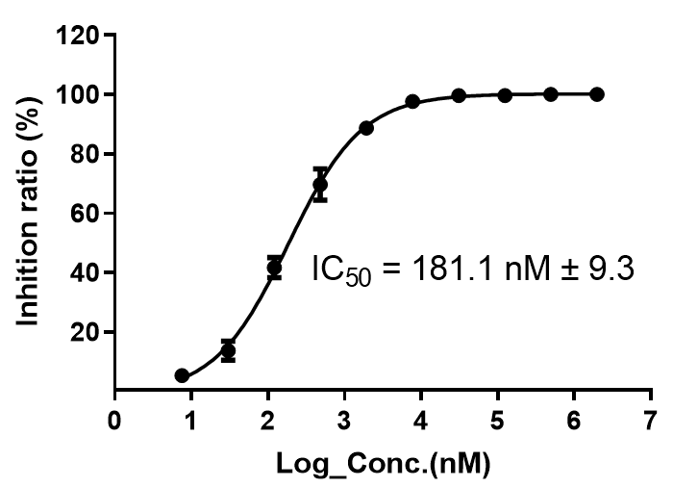
Supplementary Fig. 26. IC₅₀ of compound 4b
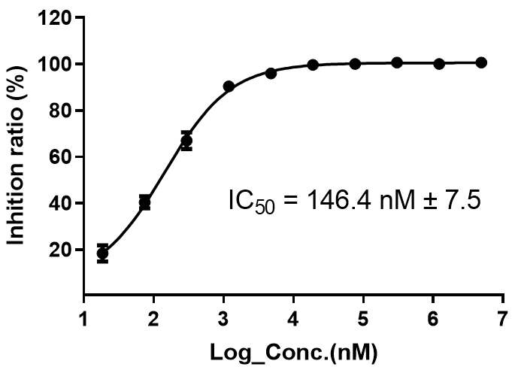
Supplementary Fig. 27. IC₅₀ of compound 4c
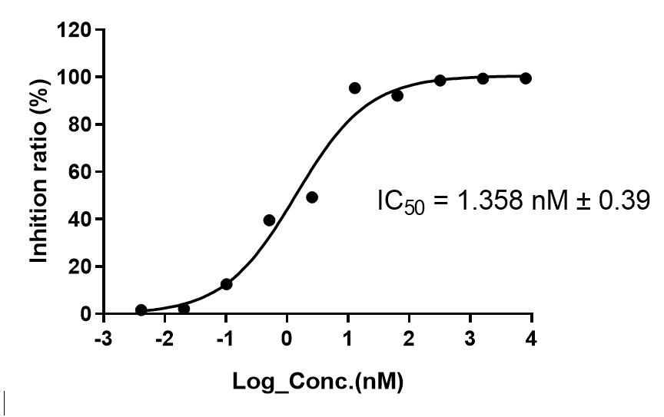
Supplementary Fig. 28. IC₅₀ of compound 4d
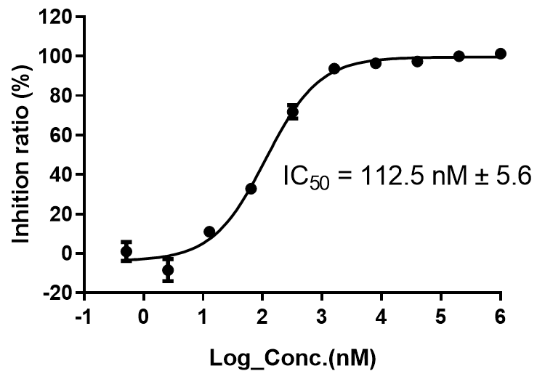
Supplementary Fig. 29. IC₅₀ of compound 4e
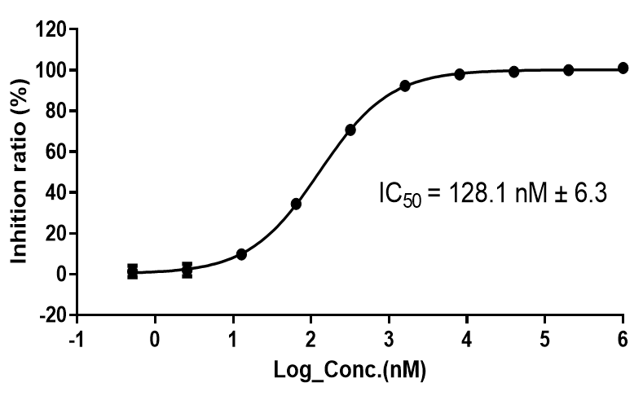
Supplementary Fig. 30. IC₅₀ of compound 4f

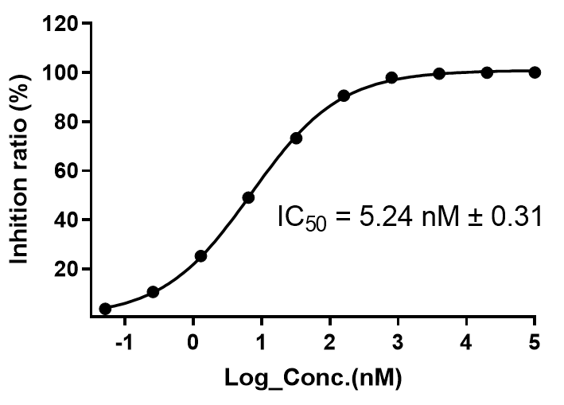
Supplementary Fig. 31. IC₅₀ of compound 4g
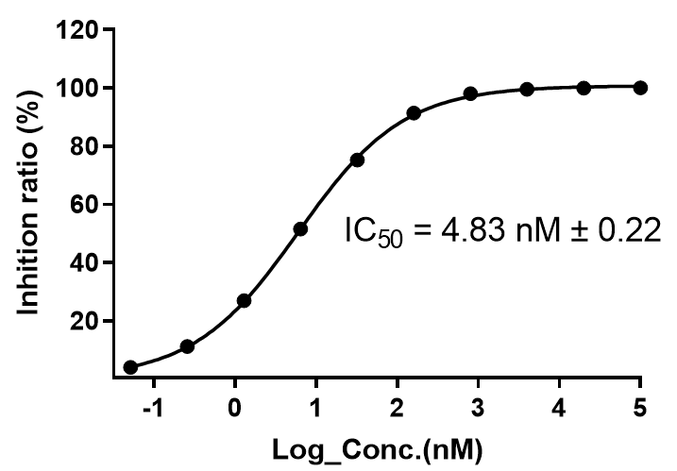
Supplementary Fig. 32. IC₅₀ of compound 4h

